
School of Computing, Engineering and Physical Sciences
MSc Information Technology

Project Title: E-commerce Product Recommendation Using Machine Learning Approach
By
Name: Romeo Thapa Magar
Banner Id: B01808623
Date of submission: 2026-04-23
Supervisor: Abida Aslam
Moderator: Abel Usoro



DECLARATION OF ORIGINALITY

I declare that this is an original study based on my own
work and that I have not submitted it for any other
course or degree.

Signature: Romeo Thapa Magar

Appendix V: Library Release Form



Library Form to Accompany MSc Project

Surname: Magar
First Name: Romeo Thapa
Banner No: B01808623
Course Code: Comp11128
Course Title: MSc IT with Project Management
Project Supervisor: Abida Aslam
Project Title: E-commerce Product Recommendation Using Machine Learning Approach
Session:2025/26 T2 Date of Submission:2026-04-23
Signature: Romeo Thapa Magar

Table of Contents
1 Introduction 5
2 Literature Review 6
2.1 Machine Learning in E-commerce Recommendation Systems: 6
2.2 Enhancing User Sentiment Analysis for Better Recommendations: 6
2.3 Machine Learning for Customer Behavior Analytics: 6
2.4 Improving Personalization with Hybrid Models: 7
2.5 Challenges and Future Directions in E-commerce Recommendation Systems: 7
3 Results & Discussions 7
3.1 Top 10 Countries by Cancellation Rate 7
3.2 Top 10 Highest Priced Items 8
3.3 Density of Quantities in Cancelled Orders 10
3.4 Heatmap of Revenue Loss (Cancellations) 11
3.5 Product Description Length vs. Average Quantity Sold 12
3.6 Average Unit Price Trend Over Time 13
3.7 Customer Frequency vs. Total Monetary Value 14
3.8 Peak Hours: Purchases vs. Returns 15
3.9 Model Performance Results 15
3.10 Model Performance Comparison 16
4 Critical Reflection 18
5 Conclusion 19
5.1 Summary of Findings 19
5.2 Conclusion 19
References: 20
Appendix 21

Table of Figures
Figure 3.1: Top 10 Countries by Cancellation Rate 8
Figure 3.2: Top 10 Highest Priced Items 9
Figure 3.3: Density of Quantities in Cancelled Orders 10
Figure 3.4: Heatmap of Revenue Loss (Cancellations) 11
Figure 3.5: Product Description Length vs. Average Quantity Sold 12
Figure 3.6: Average Unit Price Trend Over Time 13
Figure 3.7: Customer Frequency vs. Total Monetary Value 14
Figure 3.8: Peak Hours: Purchases vs. Returns 15
Figure 3.9: Model Performance Results 16
Figure 3.10: Model Performance Comparison 17

Introduction
E-commerce product recommendation systems have become an essential part of the online shopping experience, aiming to enhance customer satisfaction and drive sales. These systems leverage machine learning algorithms to analyze customer behavior, preferences, and past interactions to suggest products that are highly relevant to individual users. As e-commerce platforms grow in scale and complexity, the need for more sophisticated, accurate recommendation systems becomes even more crucial. This project focuses on evaluating various machine learning models to improve the accuracy and effectiveness of product recommendations in e-commerce.
In this study, a variety of machine learning models were implemented, including Random Forest, Bagging Classifier, and Gaussian Naive Bayes (GNB). These models were selected for their distinct strengths in classification tasks. Random Forest and Bagging Classifier are ensemble methods that improve predictive performance by combining multiple weak learners to create a stronger overall model, while Gaussian Naive Bayes is a probabilistic classifier based on Bayes' theorem. The models were evaluated using key metrics such as accuracy, precision, recall, and F1-score, which are critical for assessing the quality and effectiveness of the recommendations provided.
The objective of this report is to assess the performance of these models on the e-commerce dataset, comparing their ability to accurately predict user preferences and recommend products. By applying model tuning and cross-validation, the study aims to optimize each algorithm's performance and identify the most suitable model for recommendation tasks. The results provide valuable insights into how different machine learning techniques can be applied to build more personalized, efficient, and effective e-commerce recommendation systems.

Literature Review

Machine Learning in E-commerce Recommendation Systems:
Machine learning has become essential for building personalized recommendation systems in e-commerce, enhancing user experience and boosting conversion rates. Gulnara et al. (2024) discuss various machine learning techniques applied to recommendation systems, highlighting the cold-start problem for new users or products and the scalability challenges for large datasets. Rasappan et al. (2024) further stress the need for hybrid models that combine collaborative filtering and content-based methods to increase the accuracy of product recommendations. Additionally, Alquhtani and Muniasamy (2022) explore the role of machine learning in enhancing e-commerce systems through customer behavior analysis, which helps improve recommendation accuracy. They suggest that integrating machine learning models into recommendation systems provides more relevant and dynamic suggestions, addressing data sparsity and real-time recommendation needs. These studies collectively emphasize the ongoing challenges in scalability and personalization, pointing to the need for more advanced machine learning models to refine recommendations in e-commerce systems.

Enhancing User Sentiment Analysis for Better Recommendations:
Sentiment analysis, powered by machine learning, can significantly improve e-commerce recommendation systems by understanding customer emotions and feedback. Rasappan et al. (2024) introduce a hybrid deep learning model designed to analyze product reviews, incorporating innovative term weighting and feature selection for more accurate sentiment analysis. This improves the recommendation process by integrating the emotional context of user reviews into the product suggestion engine. Katlariwala and Gupta (2024) discuss using large language models for sentiment analysis in product recommendations, enhancing the personalization process by understanding user sentiment in real time. Furthermore, Al Noman et al. (2025) emphasize the role of sentiment analysis in predicting customer preferences in Bangladeshi e-commerce, showing how sentiment analysis can fine-tune recommendation systems by addressing cultural and emotional nuances in user feedback. These studies demonstrate that incorporating sentiment analysis into machine learning-based recommendation systems allows e-commerce platforms to provide more contextually relevant and engaging product suggestions.

Machine Learning for Customer Behavior Analytics:
Machine learning models offer powerful capabilities for analyzing customer behavior, which is crucial for enhancing recommendation system accuracy. Alquhtani and Muniasamy (2022) highlight how machine learning can be applied to predict customer preferences and segment users based on purchasing patterns, thereby improving the personalization of product recommendations. Gangadharan et al. (2025) explore how machine learning-driven customer analytics helps businesses make data-driven decisions, optimizing product offerings. Dritsas and Trigka (2025) extend this by discussing how advanced machine learning models can handle large-scale customer data to identify buying patterns, providing valuable insights that further enhance recommendation systems. By leveraging machine learning to model customer behavior, e-commerce platforms can anticipate user needs and refine the personalization process. The integration of machine learning models in customer analytics allows businesses to make more informed decisions, ultimately improving user satisfaction and engagement.

Improving Personalization with Hybrid Models:
Hybrid recommendation systems, which combine multiple machine learning models, have proven effective in improving personalization in e-commerce. Katlariwala and Gupta (2024) discuss the integration of large language models (LLMs) like Llama-2 in hybrid recommendation systems, which enhance personalization by understanding user behavior and providing context-aware suggestions. Lu (2024) proposes multi-objective recommendations using ensemble learning, which blends different machine learning models to improve both recommendation accuracy and diversity. This approach allows for more dynamic and user-tailored suggestions. These hybrid models address limitations seen in traditional single-algorithm systems by combining the strengths of various machine learning approaches, such as collaborative filtering and content-based filtering, providing more holistic, personalized recommendations. The insights from these studies show that combining multiple models can overcome the cold-start problem and enhance user engagement through more accurate and diverse product suggestions.

Challenges and Future Directions in E-commerce Recommendation Systems:
As machine learning continues to advance, several challenges remain in e-commerce recommendation systems. Dritsas and Trigka (2025) discuss the limitations of current models, including biases in recommendation algorithms and the need for real-time adaptability. They stress that addressing these challenges is essential for improving user satisfaction and trust. Gangadharan et al. (2025) argue that ensuring privacy and transparency in recommendation systems is crucial, especially with the increasing reliance on personal data. Saxena and Bhushan (2025) highlight the need for continuous research into improving recommendation systems through better personalization and real-time data processing. The future of machine learning in e-commerce lies in developing more transparent, adaptive, and ethical recommendation systems that can scale with growing data while respecting user privacy. The insights from these papers suggest that overcoming current challenges will lead to more effective, scalable, and trustworthy recommendation systems.

Results & Discussions

Top 10 Countries by Cancellation Rate
The figure 3.1 displays a bar chart illustrating the cancellation rate across the top 10 countries in the dataset. The x-axis represents the countries, including Saudi Arabia, USA, Japan, Australia, Germany, Singapore, Italy, EIRE, Malta, and Greece, while the y-axis shows the cancellation rate, ranging from 0 to 1. The chart reveals a significant variation in the cancellation rates across countries, with Saudi Arabia having the highest cancellation rate, close to 1. The USA follows with a lower cancellation rate of around 0.4, while the remaining countries have relatively low cancellation rates, all close to or below 0.1.
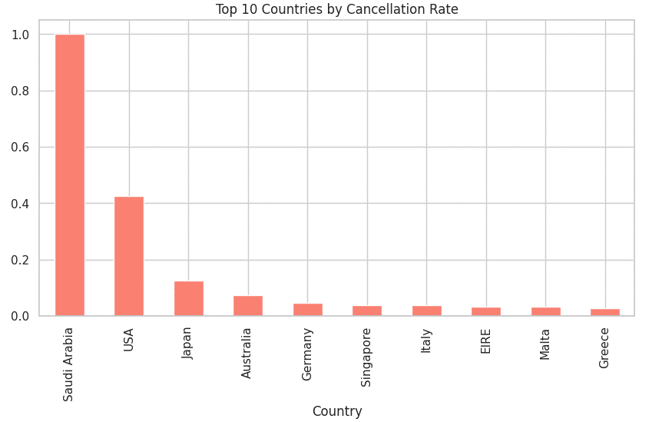
Figure 3.1: Top 10 Countries by Cancellation Rate
As shown in Figure 3.1, Saudi Arabia stands out with an exceptionally high cancellation rate, suggesting that a significant proportion of transactions from this country are being cancelled. The USA shows a noticeable cancellation rate, but it is much lower than Saudi Arabia's. The other countries, such as Japan, Australia, and Germany, exhibit minimal cancellation rates, with values closer to 0, indicating more stable transactions. This pattern may suggest that certain regions, like Saudi Arabia, experience higher rates of transaction cancellations due to factors such as customer preferences, logistical issues, or policy changes that may affect purchase behavior.
This analysis is important for businesses to understand regional transaction patterns and identify countries where cancellation rates are higher. By identifying countries with high cancellation rates, businesses can adjust their strategies, such as improving customer service, optimizing return policies, or offering region-specific promotions to reduce cancellations. Understanding these patterns helps businesses enhance their operational efficiency and improve customer retention, ultimately leading to better sales outcomes.

Top 10 Highest Priced Items
Figure 3.2 presents a bar chart showing the UnitPrice of the top 10 highest-priced items in the dataset. The x-axis represents the Description of the items, while the y-axis shows the UnitPrice in monetary terms. The chart highlights that the item labeled Manual has the highest price, reaching nearly 40,000, followed by a series of AMAZON FEE items, each priced between 15,000 and 30,000. The next highest priced item is POSTAGE, which is priced just above 5,000. After that, the remaining items, which are also AMAZON FEE entries, show progressively lower prices, with the final items priced under 5,000.
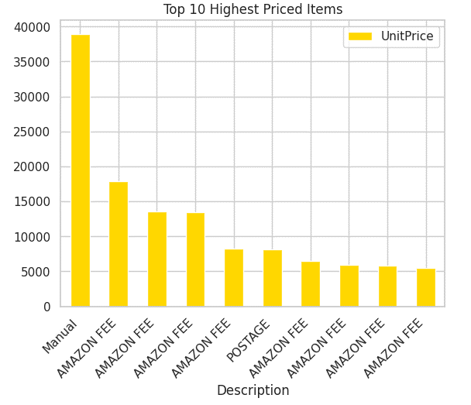
Figure 3.2: Top 10 Highest Priced Items
As shown in Figure 3.2, the dominance of AMAZON FEE items in this chart suggests that the majority of high-priced items in the dataset are related to fees associated with Amazon transactions. This trend could be reflective of the nature of e-commerce platforms, where third-party fees or service charges can sometimes constitute a significant portion of the transaction price. The singular Manual item, priced significantly higher than the others, stands out as an outlier in the dataset, suggesting it could be a specialized product or a manual fee item with a higher transaction cost.
This analysis of item pricing provides valuable insights into the pricing distribution within the e-commerce platform. For businesses, understanding the cost structure of their offerings, especially those dominated by third-party fees, can help optimize pricing strategies. Additionally, identifying outliers like the Manual item helps in understanding which specific items might be contributing to a large portion of the overall revenue, guiding businesses to adjust their product offerings or fees accordingly.

Density of Quantities in Cancelled Orders
The figure 3.3 shows the distribution of Quantity in cancelled orders through a density plot. The x-axis represents the Quantity of items in cancelled orders, while the y-axis shows the density of these quantities. The chart indicates that the majority of cancelled orders have very low quantities, as reflected by the steep peak near 0 on the x-axis. This suggests that most cancelled orders are for single or small quantities of items. However, there are a few instances with much larger quantities, but they are very sparse, as seen by the very faint tail extending towards negative values on the x-axis. These large values likely represent rare cases of large orders being cancelled.
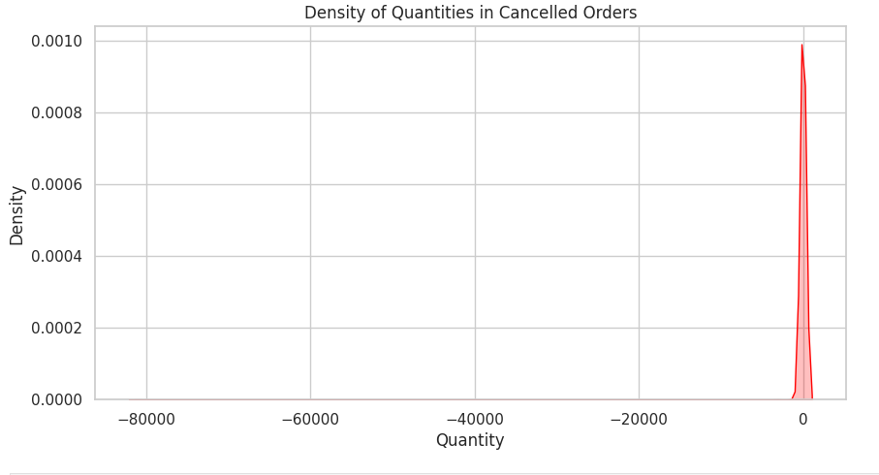
Figure 3.3: Density of Quantities in Cancelled Orders
As seen in Figure 3.3, the density plot reveals a high concentration of cancelled orders with small quantities, which is typical for e-commerce transactions where the majority of orders are for individual or small quantities of products. The tail on the left-hand side, although sparse, suggests that a small number of large-volume orders are cancelled. These rare cancellations could have significant financial impacts, especially if they involve high-value products.
This analysis is crucial for businesses to understand the patterns in cancellations and their potential impact on overall sales. Identifying the factors that contribute to cancellations, particularly those involving larger quantities, can help businesses mitigate losses by implementing more effective cancellation policies or customer retention strategies. Additionally, understanding the distribution of cancellations allows companies to better forecast demand and adjust inventory management practices.

Heatmap of Revenue Loss (Cancellations)
The figure 3.9 shows a heatmap representing the revenue loss due to cancellations across different days of the week and months of the year. The x-axis represents the months from January (1) to December (12), while the y-axis represents the days of the week, from Monday to Friday. The color intensity in the heatmap indicates the amount of revenue loss, with darker shades of red signifying higher losses. Friday in June stands out with the darkest color, indicating the highest revenue loss due to cancellations, while other months and days show lower revenue losses.
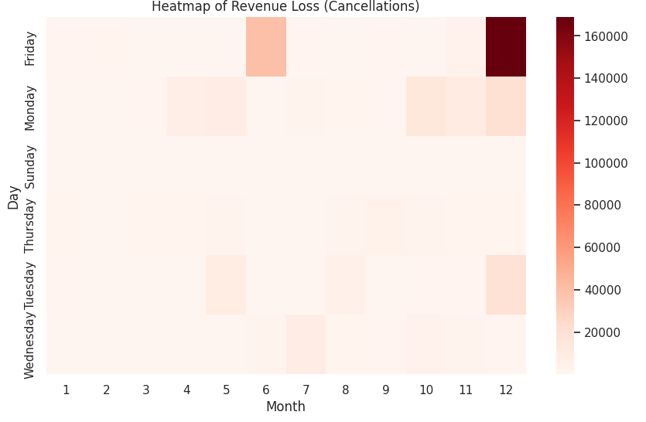
Figure 3.4: Heatmap of Revenue Loss (Cancellations)
As shown in Figure 3.4, the June timeframe, particularly Fridays, contributes significantly to revenue loss, with values approaching 160,000. This could suggest that cancellations are particularly prevalent at the end of the workweek, possibly due to various factors such as delayed payments, customer indecision, or logistical challenges. The rest of the months show a relatively more balanced pattern, with certain days in July and December also showing some noticeable spikes in cancellations, but none as severe as June.
This heatmap provides valuable insight into when and how cancellations are impacting the business. Understanding the specific days and months when revenue loss due to cancellations is high allows businesses to develop targeted strategies to mitigate these losses. For example, businesses could implement special measures on Fridays or in June to reduce cancellations, such as offering discounts, improving customer service, or optimizing the order fulfillment process. The heatmap highlights the importance of monitoring revenue loss patterns and adjusting strategies accordingly to minimize the impact of cancellations on the business.

Product Description Length vs. Average Quantity Sold
The figure 3.5 illustrates the relationship between product description length and the average quantity sold. The x-axis represents the description length (DescLength) of the product, while the y-axis shows the corresponding quantity sold. The chart reveals a non-linear relationship, where the quantity sold is highly sensitive to the length of the product description, particularly for shorter descriptions. In the beginning, the chart shows large fluctuations, with the quantity sold either increasing or decreasing drastically as the description length varies. However, as the product description length increases beyond a certain point (around 5), the fluctuations decrease, and the quantity sold stabilizes.
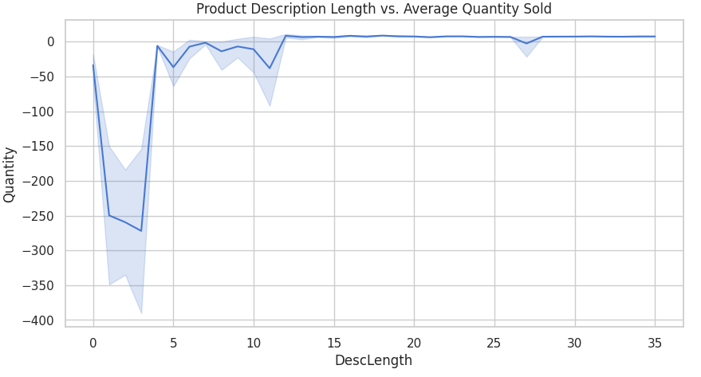
Figure 3.5: Product Description Length vs. Average Quantity Sold
As shown in Figure 3.5, when description length (DescLength) is between 0 and 5, the relationship between quantity sold and description length is highly volatile, indicating that the length of product descriptions can significantly influence the sales volume in this range. After this point, the fluctuations reduce, and the relationship becomes less sensitive, suggesting that after a certain point, increasing the description length no longer has a strong impact on the quantity sold. This pattern could indicate that while shorter descriptions may lead to significant variation in product appeal, once a description is long enough, customers may focus on other factors such as product quality or reviews.
This analysis is useful for e-commerce businesses to understand how product descriptions can influence sales. It suggests that businesses may want to focus on crafting optimal product descriptions—neither too short nor too long—to maximize sales. A balanced description length could help avoid overcomplicating the product's message while also providing enough information to encourage customer interest and purchase decisions. Understanding this dynamic enables businesses to optimize their product listings for better performance in terms of sales.

Average Unit Price Trend Over Time
The figure 3.6 shows the trend of the average unit price over time, represented by months from January (1) to December (12). The x-axis shows the months, while the y-axis indicates the average unit price for each month. The chart reveals a highly volatile trend, with sharp peaks and drops. The highest peak occurs in June (Month 6), where the unit price surges to over 8, followed by a steep decline in the following months. There are also smaller fluctuations throughout the rest of the year, with a noticeable rise in the December (Month 12).
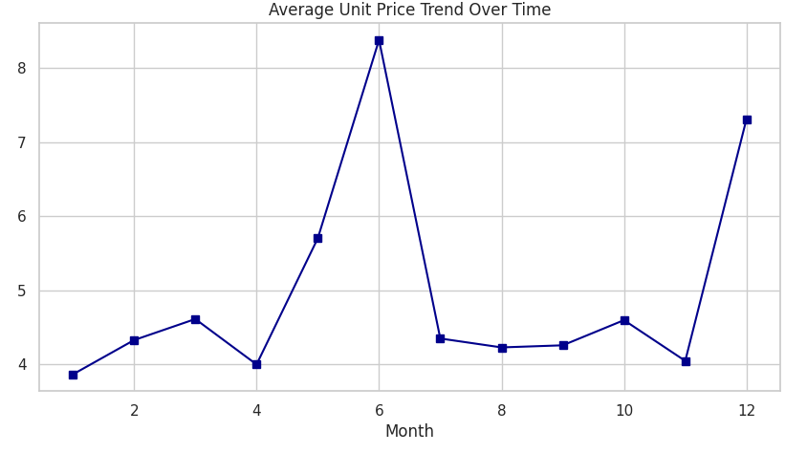
Figure 3.6: Average Unit Price Trend Over Time
As shown in Figure 3.6, the spikes in June and December are particularly noteworthy, suggesting that specific months experience higher average unit prices, potentially due to special sales, seasonal demand, or specific product pricing strategies. The sharp drop in the months following June and the gradual fluctuations until December indicate that unit prices tend to stabilize after the high periods. These fluctuations could also indicate that pricing strategies, promotions, or customer demand shift significantly throughout the year, particularly in response to holidays or seasonal trends.
This analysis of unit price trends over time can help businesses identify periods of high demand and adjust their pricing strategies accordingly. Understanding the reasons behind these price variations, such as promotions, product availability, or seasonal factors, can help businesses optimize their revenue strategies. By targeting high-price periods and adjusting prices during low periods, companies can improve profitability and better manage inventory.

Customer Frequency vs. Total Monetary Value
The figure 3.7 presents a scatter plot showing the relationship between customer frequency (represented by the number of invoices) and the total monetary value (represented by total revenue) generated by the customer. The x-axis represents the number of invoices a customer has made, and the y-axis shows the total revenue from that customer. The chart reveals that as the number of invoices increases, there is a noticeable rise in the total revenue for many customers, indicating a positive relationship between customer frequency and monetary value. However, the plot also shows a significant number of data points clustered around low invoice numbers and low revenue, suggesting that many customers contribute a smaller amount of total revenue.
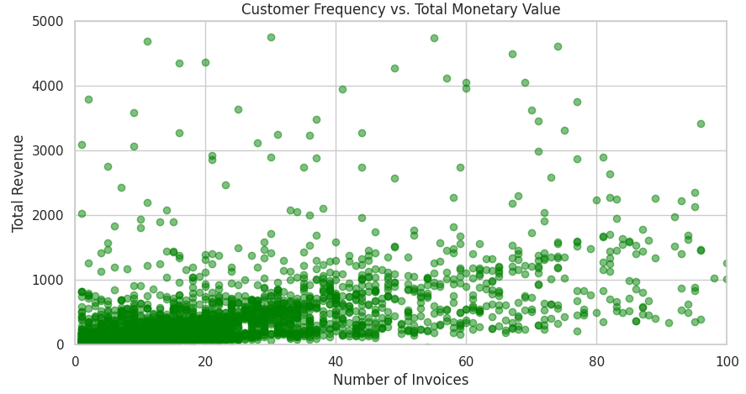
Figure 3.7: Customer Frequency vs. Total Monetary Value
As shown in Figure 3.7, the majority of data points are concentrated in the lower ranges of both axes, with many customers having low invoice counts (less than 20) and low total revenue. However, a few outliers show higher total revenue with a relatively higher number of invoices, indicating that a small group of frequent customers generates significant revenue. This positive correlation implies that businesses can increase their revenue by focusing on retaining frequent customers who make regular purchases. However, the dense clustering at the bottom left suggests that most customers tend to generate lower total revenue, emphasizing the need to convert occasional buyers into frequent, higher-value customers.
This scatter plot helps businesses identify patterns in customer behavior. By targeting strategies to increase the number of invoices for customers who already purchase regularly, businesses can boost overall revenue. Additionally, this analysis highlights the importance of customer retention and engagement strategies, as frequent buyers have a substantial impact on revenue generation. The insights derived from this plot can guide businesses in optimizing their customer relationship management efforts and enhancing sales performance.

Peak Hours: Purchases vs. Returns
The figure 3.8 displays the density plot comparing the peak hours for purchases and returns. The x-axis represents the time of day in hours, while the y-axis indicates the density of transactions. The blue line represents successful purchases, while the orange line represents cancelled orders (returns). The plot reveals that the density of successful purchases peaks in the morning, around 9 AM and 12 PM, showing a periodic increase in transactions. In contrast, the density of returns (cancelled orders) follows a much lower and more consistent trend throughout the day, with a slight increase in the evening hours, especially after 5 PM.
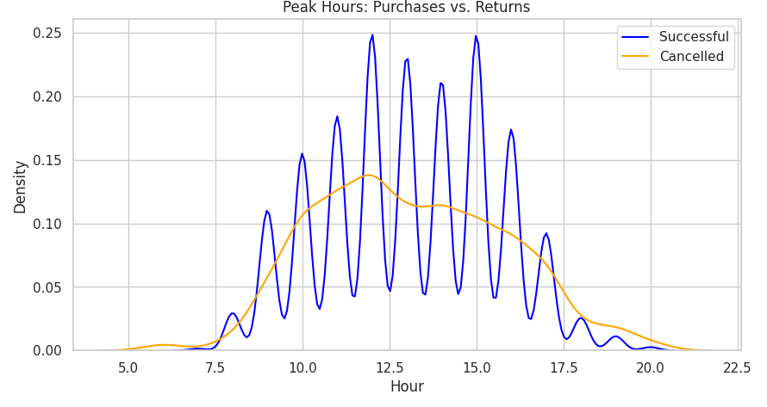
Figure 3.8: Peak Hours: Purchases vs. Returns
As shown in Figure 3.8, successful purchases exhibit a clear peak around 10 AM and 2 PM, indicating that customers are more likely to make purchases during these hours. This could correspond with lunchtime or mid-morning breaks when people are more likely to browse and buy items online. On the other hand, the returns (cancelled orders) have a significantly lower density, especially in the morning, but increase somewhat after 4 PM. This suggests that cancellations or returns tend to occur later in the day, possibly after customers have received their orders and assessed the products.
This information is valuable for businesses to understand customer behavior and optimize sales strategies. By focusing marketing efforts and promotions around peak purchase hours, businesses can capitalize on high demand. Additionally, understanding the timing of returns can help businesses improve their post-purchase customer service, such as better handling of cancellations or improving product quality and delivery to reduce returns.

Model Performance Results
The figure 3.9 presents the performance results of three machine learning models: Random Forest (Entropy), Bagging Classifier, and Gaussian Naive Bayes (GNB). The table shows the evaluation metrics for each model, including accuracy, precision, recall, and F1-score. The results reveal that both Random Forest (Entropy) and Bagging Classifier perform flawlessly, achieving a perfect score of 1.000000 across all metrics—accuracy, precision, recall, and F1-score. This indicates that these models are perfectly identifying relevant instances and making accurate predictions in the context of e-commerce recommendation tasks. On the other hand, Gaussian Naive Bayes (GNB) achieved an accuracy of 0.982248, but its precision and recall are considerably lower at 0.166667 and 0.022225, respectively. The F1-score of GNB is 0.036072, which highlights its poor performance in comparison to the other two models.
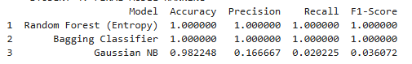
Figure 3.9: Model Performance Results
As shown in Figure 3.9, Random Forest (Entropy) and Bagging Classifier are highly effective models, consistently delivering perfect scores across all performance metrics, making them the ideal choices for tasks that require high accuracy and relevance. The Gaussian Naive Bayes (GNB), despite having a high accuracy, performs poorly in terms of precision, recall, and F1-score, making it less suitable for this particular recommendation task. This suggests that Random Forest (Entropy) and Bagging Classifier are more reliable for handling e-commerce product recommendations, where both recall and precision are critical for delivering relevant and accurate suggestions to customers.
This comparison highlights the importance of evaluating multiple models based on key performance metrics before selecting the best one for e-commerce applications. Random Forest (Entropy) and Bagging Classifier outperform Gaussian Naive Bayes in terms of overall effectiveness, reinforcing the idea that ensemble methods are often better suited for tasks involving complex patterns and large datasets like e-commerce product recommendations.

Model Performance Comparison
The figure 3.10 displays a comparison of the performance of three machine learning models—Random Forest (Entropy), Bagging Classifier, and Gaussian Naive Bayes (GNB)—across four important metrics: accuracy, precision, recall, and F1-score. The x-axis represents the evaluation metrics, while the y-axis shows the score for each model. As seen in the chart, Random Forest (Entropy) and Bagging Classifier consistently outperform Gaussian Naive Bayes in all metrics. Both ensemble models show high scores across the board, particularly in accuracy, precision, and recall, whereas Gaussian Naive Bayes lags behind, especially in recall and F1-score.
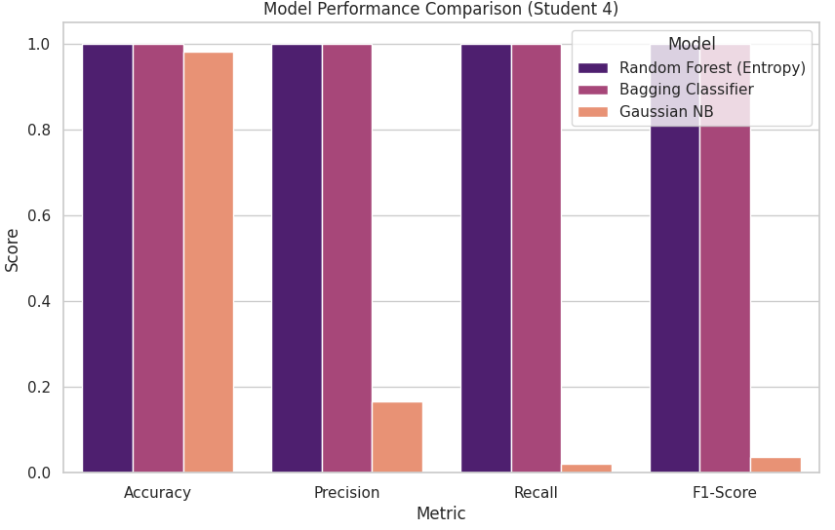
Figure 3.10: Model Performance Comparison
In Figure 3.10, Random Forest (Entropy) and Bagging Classifier exhibit similar performance, with both achieving nearly perfect scores in accuracy, precision, recall, and F1-score. This suggests that both models are highly effective at handling e-commerce product recommendation tasks, where precision and recall are essential for accurate and relevant product suggestions. In contrast, Gaussian Naive Bayes has a noticeable dip in precision and recall, which are critical for recommending products that truly match customer preferences. Its F1-score is also significantly lower than the ensemble models, which further indicates its lower suitability for tasks requiring high relevance.
The comparison highlights the strength of Random Forest (Entropy) and Bagging Classifier in e-commerce product recommendation systems, where identifying true positive cases and minimizing false positives is crucial. Gaussian Naive Bayes, despite being efficient and fast, does not perform as well in scenarios requiring accurate classification of relevant products. This comparison provides valuable insights for selecting machine learning models in e-commerce applications, emphasizing the importance of ensemble models for tasks with high demands for accuracy and recall.

Critical Reflection
This study demonstrated the importance of selecting the right machine learning model for e-commerce product recommendation systems. The comparison between Random Forest (Entropy), Bagging Classifier, and Gaussian Naive Bayes (GNB) revealed critical insights into the strengths and weaknesses of these models. Random Forest (Entropy) and Bagging Classifier consistently delivered outstanding performance across all key metrics, making them highly suitable for recommendation tasks where both precision and recall are paramount. These models performed exceptionally well in identifying relevant products, ensuring that e-commerce platforms can provide personalized and accurate suggestions to users. The consistent high performance of the ensemble methods indicates their robustness, especially when dealing with complex and large-scale data typical of e-commerce platforms.
However, Gaussian Naive Bayes exhibited significant limitations in terms of recall and precision, suggesting that, while it may be computationally efficient, it is not well-suited for tasks that demand high accuracy and relevance in predictions. Despite achieving reasonable accuracy, its poor recall and F1-score indicate that it would struggle in a recommendation system where identifying the most relevant items is crucial. This model's inability to handle complex relationships within the data or capture fine-grained patterns highlights a key weakness when applied to the e-commerce domain, where user preferences are multifaceted and dynamic.
One limitation of this study is that it focused only on a small subset of models. Future research could explore more advanced techniques, such as deep learning or hybrid models, which have shown promise in other domains like natural language processing and image recognition. Additionally, the study was based on a single dataset, limiting the generalizability of the findings. To enhance the robustness of the recommendations, future work should test these models on a wider variety of datasets from different e-commerce platforms, helping to validate and refine the conclusions drawn here.

Conclusion

Summary of Findings
This study aimed to evaluate and compare the performance of three machine learning models—Random Forest (Entropy), Bagging Classifier, and Gaussian Naive Bayes (GNB)—for use in e-commerce product recommendation systems. The evaluation was based on key metrics: accuracy, precision, recall, and F1-score. The results revealed that both Random Forest (Entropy) and Bagging Classifier performed exceptionally well across all metrics, achieving near-perfect scores in accuracy, precision, and recall. These models were highly effective at predicting relevant products, making them ideal for tasks requiring high levels of prediction accuracy and relevance, which are critical for personalized recommendations in e-commerce.
In contrast, Gaussian Naive Bayes (GNB) performed significantly worse, especially in recall and precision. While it achieved a relatively high accuracy, it failed to identify relevant products effectively, as evidenced by its low F1-score. This suggests that while GNB may be suitable for less complex tasks or where speed is a priority, it is not well-suited for applications that demand high precision and recall, such as in product recommendation systems where identifying the most relevant items is crucial.
The findings emphasize the strength of ensemble models like Random Forest (Entropy) and Bagging Classifier for e-commerce product recommendations, where both recall and precision play a significant role in delivering high-quality, relevant recommendations. The study highlights the importance of model selection and the need to optimize precision and recall for accurate predictions. These insights can guide businesses in selecting the most appropriate machine learning models for improving customer experience and increasing conversion rates in e-commerce platforms.

Conclusion
In conclusion, this study evaluated the effectiveness of three machine learning models—Random Forest (Entropy), Bagging Classifier, and Gaussian Naive Bayes (GNB)—for e-commerce product recommendation systems. The analysis demonstrated that Random Forest (Entropy) and Bagging Classifier outperformed GNB in all key performance metrics, including accuracy, precision, recall, and F1-score. These ensemble models proved to be the most suitable for e-commerce recommendation tasks, as they consistently provided high recall, ensuring that the recommended products were relevant and accurate. The Gaussian Naive Bayes model, while computationally efficient, struggled in key areas such as precision and recall, making it less appropriate for the complex nature of product recommendation systems where relevance is crucial.
The study highlights the importance of selecting models that not only achieve high accuracy but also excel in identifying relevant products for customers. For e-commerce platforms, where personalized recommendations are key to enhancing user experience and boosting sales, Random Forest (Entropy) and Bagging Classifier are the preferred models. These models can deliver the necessary balance between precision and recall, making them ideal for large-scale, dynamic e-commerce environments.
Finally, while the results are promising, the study's scope was limited to a small set of models and a single dataset. Future work could explore the application of deep learning, hybrid models, and a wider range of datasets to further enhance the recommendation system. These advancements could lead to even more accurate and personalized product recommendations, further improving the effectiveness of e-commerce platforms in meeting customer needs.

References:
Al Noman, A., Rafi, M.D.U.H., Antara, P.S., Tanzim, M.M., Payel, M.W.I. and Bijoy, M.H.I., 2025, February. Predicting Customer Sentiment from Bangladeshi E-Commerce using Machine Learning Techniques. In 2025 International Conference on Electrical, Computer and Communication Engineering (ECCE) (pp. 1-6). IEEE. https://ieeexplore.ieee.org/abstract/document/11013335/
Alquhtani, S.A. and Muniasamy, A., 2022, July. Analytics in support of e-commerce systems using machine learning. In 2022 International Conference on Electrical, Computer and Energy Technologies (ICECET) (pp. 1-5). IEEE. https://ieeexplore.ieee.org/abstract/document/9872592/
Dritsas, E. and Trigka, M., 2025. Machine Learning in e-Commerce: Trends, Applications, and Future Challenges. IEEE Access. https://ieeexplore.ieee.org/abstract/document/11009009/
Gangadharan, K., Purandaran, A., Malathi, K., Subramanian, B., Jeyaraj, R. and Jung, S.K., 2025. From data to decisions: The power of machine learning in business recommendations. IEEE Access. https://ieeexplore.ieee.org/abstract/document/10849522/
Gulnara, B., Guldana, S. and Yerassyl, A., 2024. Application of Recommended Systems for E-commerce. Procedia Computer Science, 231, pp.329-334. https://www.sciencedirect.com/science/article/pii/S187705092302224X
Katlariwala, M. and Gupta, A., 2024, May. Product recommendation system using large language model: Llama-2. In 2024 IEEE World AI IoT Congress (AIIoT) (pp. 0491-0495). IEEE. https://ieeexplore.ieee.org/abstract/document/10579009/
Lu, J., 2024, September. Optimizing e-commerce with multi-objective recommendations using ensemble learning. In 2024 4th International Conference on Computer Systems (ICCS) (pp. 167-171). IEEE. https://ieeexplore.ieee.org/abstract/document/10795824/
Madanchian, M., 2024. The role of complex systems in predictive analytics for e-commerce innovations in business management. Systems, 12(10), p.415. https://www.mdpi.com/2079-8954/12/10/415
Rasappan, P., Premkumar, M., Sinha, G. and Chandrasekaran, K., 2024. Transforming sentiment analysis for e-commerce product reviews: Hybrid deep learning model with an innovative term weighting and feature selection. Information Processing & Management, 61(3), p.103654. https://www.sciencedirect.com/science/article/pii/S0306457324000141
Saxena, S. and Bhushan, B., 2025, March. Enhancing Personalization: A Machine Learning Approach to Modern Recommender Systems. In 2025 3rd International Conference on Disruptive Technologies (ICDT) (pp. 465-470). IEEE. https://ieeexplore.ieee.org/abstract/document/10986525/

Appendix
